logo-laureate1 (1).jpg



**FULLY INDIGENOUS GUIDE AND MULTIMEDIA ROBOT: *“Pratham[1]”***

**Team members**Jatin Kumar Khilrani (Firmware development*), Akash Srivastava (Hardware design & interfacing**\***), Ishan Upadhyay (Mechanical structure, CAD**\***),

Shantmanu (System Evaluator and PR leader*).

[Bachelor of Technology (B.Tech) in Electronics, 3rd year]

**Under guidance of**

Mr. Rajesh Singh and Mr. Vivek Kaundal

[Department of Electronics, Instrumentation and Control]

1. **About the University of Petroleum & Energy Studies (UPES)**

UPES was established in the year 2003 through UPES Act, 2003 of the State Legislature of Uttarakhand. With an ambitious vision and unique approach, UPES emerged as an innovative institution offering programs that are specifically designed for core sectors with high growth projections. Focused on the requirements of the future, UPES offers a wide spectrum of globally competitive undergraduate, postgraduate and doctorate programs in Energy, Infrastructure and Transportation (EIT) and other growth sectors. The University’s objective is to develop domain specific and competent technocrats, professionals and managers who are ready to join the core industries.

1. **Scope**

The robot is designed to welcome to the university and guide visiting guests. Generally the visitors can be categorized as such for placement activity, dignitaries from:

1. Reputed Universities in India & abroad,
2. Industrial expertise and stake holders.
3. Regulatory & affiliating bodies and
4. Visiting professors etc.

We are designing a robot which will welcome and guide with appropriate multimedia information. This could be for some of the pre-defined areas of our campus. The robot will pick up from the main reception proceeding to R&D center, library, placement block, Management Development Block and there after culminate back at main reception of UPES, Dehradun.

Phase I comprises of Conceptual Design Presentation and Project Proposal. The robotic application to develop has been named PRATHAM. PRATHAM intends to accomplish the following:

1. On-campus mobile guide equipped with 5- Axis arm, adjustable height of HDMI display, encoder motors, sonar sensor, Zigbee & digital compass sensor.
2. Robot is capable to speak the pre-programmed information and in user mode it will be handled by the technical expert in the control room.

**The system characteristics are as follows:**

1. On board computer **RaspberryPi** credit-card-sized [**single-board computer**](http://en.wikipedia.org/wiki/Single-board_computer), used for multimedia support.
2. Zigbee and Wi-Fi network.
3. RFID, to initialize robot.
4. Robotic Arm, used to welcome guest.
5. Google API- text to speech, internet services applicable.
6. Move in narrow places, where big vehicles can’t move.
7. In User mode, it can answer almost every question.
8. We can interact indirectly to the guest.
9. Path- Learning with help of encoded motors and compass.
10. Flexible system can be programmed according to the user.

Our approach is to build a robot that can educate, entertain and provide a glimpse of the university and its facilities. The robot’s purpose is to:-

1. Guide people through UPES, detailing the surrounding as they go always.
2. Explain the surroundings through video/audio and displaying some detail on HDMI display.
3. Respond to visitors questions through predefined stored answers.
4. Enable people all around the world to establish a “virtual presence” in the place, using a Web interface to watch the robot operate and send it to speciﬁc target locations.
5. Zigbee nodes are used to identify the location for any defined tasks multimedia or guide is to be done.

**The above mentioned robot will work in two modes.**

1. ***Autonomous Mode***

* In Autonomous mode the robot will move by encoder wheels, Digital compass, Bumpers and sonar sensor.
* In this mode the different parameters of the robot will be set to default values or to the values that are set by the user through serial communication.
* The microcontroller has sensors. It receives values from these sensors and analyses them to take proper decisions about movement of robot.

After taking the accurate decisions it gives appropriate instructions to the motor for movement.

1. ***User Mode***

* The default mode of PRATHAM is ‘USER MODE’. The movement of robot in this mode is guided by the user unlike in the autonomous mode where only microcontroller controls the complete functioning of robot.
* The method of operating robot in the user mode. With the help of two PCs connected wirelessly and one which is connected with the robot act as on board PC and the other act as off board PC.
* Google API, Google translate services for mimicry.
* We use time lapse camera control to live capture the surrounding image and surrounding audio is capture through microphone.

**3-Features**

|  |  |  |  |  |  |
| --- | --- | --- | --- | --- | --- |
| Mechanical Specifications | | Software Specifications | | **Electronics Specifications** | |
| Two wheel Differential drive | *For smooth drive* | Raspberry-Pi running Linux (To be Implemented) | *Wide range in multimedia support* | Rugged solid state components | No moving disks  1 x Serial ports |
| 1024 tick encoded motors, 19.5cm wheels | F*or autonomous mode* | Programming in “C” | *For configuring general sensors and motors* | Accelerometer | *Avoid tilting of Robot* |
| Sturdy all-metal chassis | *For rigidness* | Programming of Ardunio  Board. | For robotic arm. | Rugged solid state components | no moving disks |
| Speed upto 0.5 metre/sec. and Payload upto 20 kgs.- | *make it capable for work in tough condition* | Embedded ARM- cortex based 100 MHz  microcontroller board | *fast processing* | 1 x Serial ports (USB Hub. | Can easily be extended up to 2) |
| Powered by three hot-swappable SMF batteries.- | *For its long life* | Scalable firmware architecture |  | USB Wi-Fi routers | *For interaction* |
| Height Adjustable LCD stand | *for make it user friendly* | Fully open source- | *user friendly*  *Raspbian operating system* | USB Camera  USB microphone.  Stereo Speakers. – |  |
| 4- Axis Robotic Arm.- | *For welcoming the guest* |  |  | Front Sonar Array (1x8)  Rear sonar array (1x8) |  |
| Fault tolerant design- | *To make it smart and intelligent* |  |  | Front and rear segmented bumpers (1x5)- | *Avoid accidents and obstacles in the path* |

**4-CAD Model- *“Pratham”***

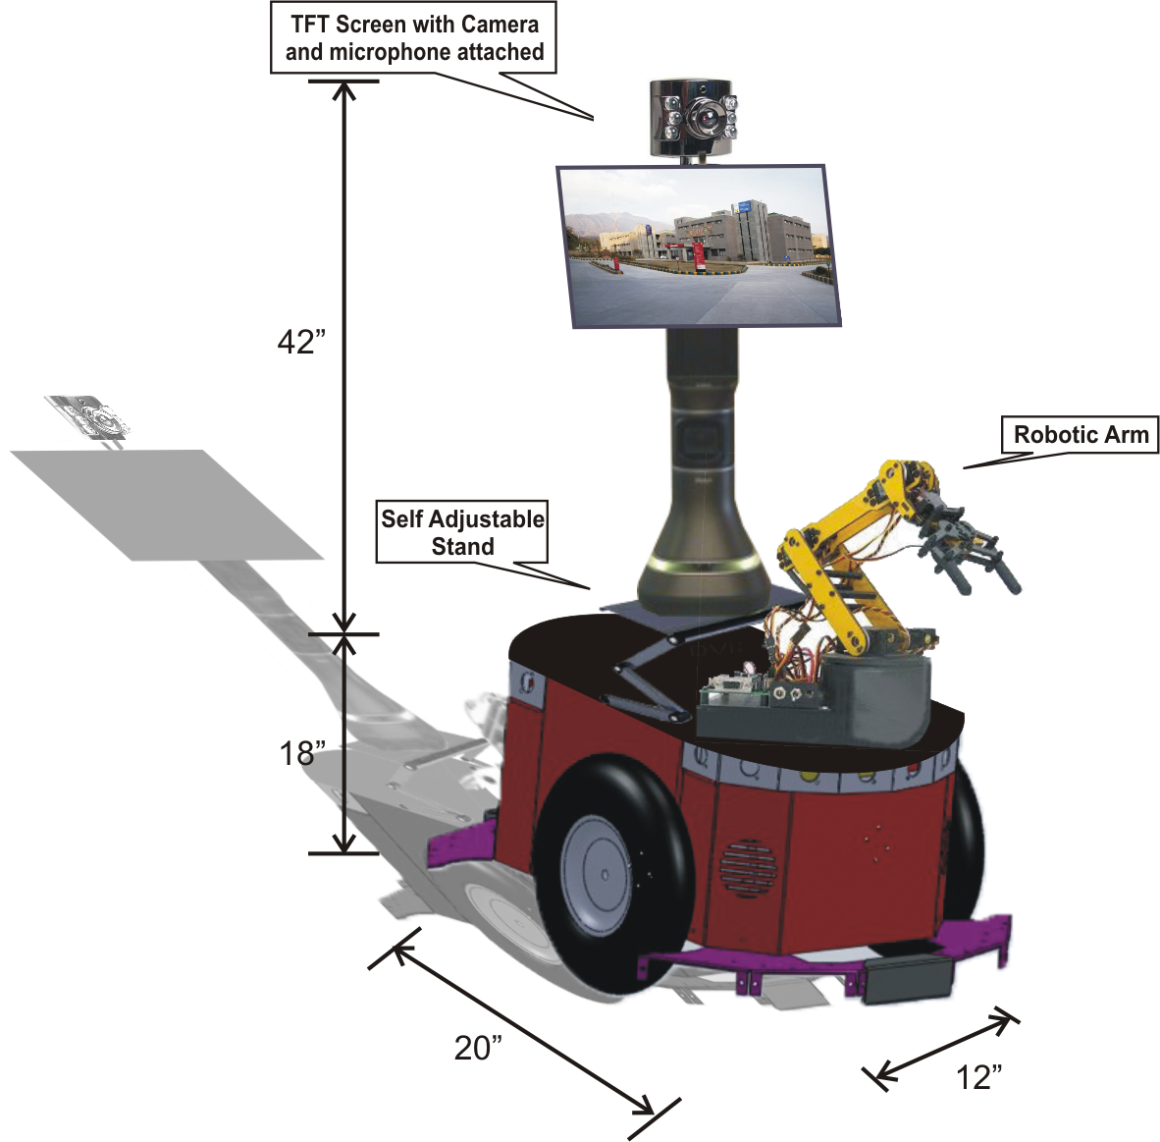

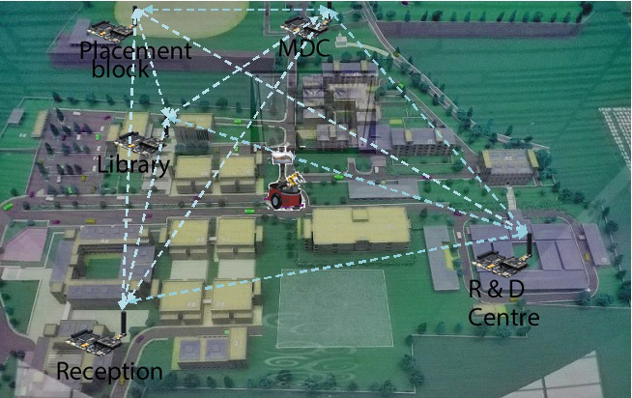

**RF Link of Pratham Robot in UPES, Dehradun**

1. **Plan**

**5.1 Methodology/Time plan:-**

|  |  |  |  |
| --- | --- | --- | --- |
| **#** | **Month** | **week** | **work description** |
| **1** | October | Week 1/2 | launch of contest and Release of letter |
| Week 3/4 | Conceptual Design- Phase I |
| **2** | November | Week 1/2 | 1st round presentation on our project prototype. |
| Week 3/4 | Final round presentation and proposal making. |
| **3** | December | Week1/2/3/4 | Registration with Final proposal and video. |
| **4** | January | Week 1/2 | Mechanical hardware design. |
| Week 3/4 | Fabrication of the mechanical design. |
| **5** | February | Week 1/2 | Software and Wireless node implementation. |
| Week 3/4 | Software and wireless node verification. |
| **6** | March | Week 1/2 | Mechanical and electronic components testing. |
| Week 3/4 | Unit testing of project.  Finishing and final submission |

**5.2 Marketing Plan**

1. Once the proposal is accepted, design as per the desired specifications.

2. Our PR team will seek for external funding to design the Robot.

3. PR team will entertain media for the publicity of the robot like Tube videos, Facebook, Twitter etc. mainly all the social media.

4. Experience sharing on the Robot, with the customers at shopping Malls, institutional/ University Campus.

**6. Budget**

1. **Hardware Tools**

|  |  |  |  |  |
| --- | --- | --- | --- | --- |
| **#** | **Product Name** | **Quantity** | **Total Cost INR** | **Total cost (US$) (1US$=63.24 INR)** |
| 1 | Chassis | 1 | 60,000 | 948.76 |
| 2 | Robotic Arm | 2 | 30,000 | 474.38 |
| 3 | Display Stand Structure | 1 | 30,000 | 474.38 |
| 4 | PCB designing + Component | 5 | 25,000 | 395.31 |
| 5 | Zigbee module | 5 | 25,000 | 395.31 |
| 6 | RFID | 1 | 19,900 | 316.25 |
| 7 | HDMI display | 1 | 17,000 | 268.81 |
| 8 | Sonar Sensor | 8 | 14,400 | 227.7 |
| 9 | GPS Module | 1 | 10,000 | 158.12 |
| 10 | Motor | 2 | 7,000 | 110.68 |
| 11 | Accelerometer | 1 | 6,700 | 105.95 |
| 12 | Tyres | 2 | 6,000 | 94.87 |
| 13 | Courier Service Charge | - | 4,000 | 63.25 |
| 14 | Raspberry Pi | 1 | 3,800 | 60.08 |
| 15 | Arm Board | 1 | 3,000 | 47.43 |
| 16 | Battery | 3 | 3,000 | 47.43 |
| 17 | Motor Driver Keypad LCD | 1 | 2,700 | 42.69 |
| 18 | USB camera | 1 | 2,000 | 31.62 |
| 19 | Charger | 1 | 2,000 | 31.62 |
| 20 | Arm I/O extension board | 1 | 2,000 | 31.62 |
| 21 | Speaker | 1 | 1,600 | 25.3 |
| 22 | USB microphone | 1 | 1,000 | 15.81 |
| 23 | USB Wi-Fi dongle | 1 | 600 | 9.48 |
| 24 | Caster Wheel | 1 | 500 | 7.9 |
| 25 | Bumper Sensor | 8 | 400 | 6.32 |
| 26 | Miscellaneous |  | 20,000 | 316.25 |
|  |  | **TOTAL** | * **2,97,500** | **US$ 4704** |
| *taxes extra as applicable* | | | | |

**B. Promotional expenses**

|  |  |  |  |
| --- | --- | --- | --- |
| **#** | **works** | **Cost (INR)** | **Cost (US$)** |
| 1. | Publicity  *(Newspaper articles/ News/ Website design/ Banners/ Posters/ Social media)* | 77,000 | 1200 |
|  | **Total** | * **77,000** | **US$ 1200** |

**C. Travel and Logistics**

|  |  |  |  |  |  |
| --- | --- | --- | --- | --- | --- |
| **#** |  | **Quantity** | **Unit Rate INR** | **Cost INR** | **Cost (US$)** |
| 1 | Travelling charges (return) | 5 persons | * 60,000/person | Rs 3,00,000 | 4743.83 |
| 2 | Hotel charges for 5 days | 3 rooms, 15 man-rooms | 15500/room | Rs 1,39,500 | 2205.88 |
| 3 | Food expenses | 5 persons | $100/day | Rs 1,58,100 | 2500.00 |
|  |  |  | **Total** | * **5,97,600** | **US$ 9450.00** |

**E. Grand Total(A+B+C)=INR -9,72,100($15,371)**

1. “Pratham” means First in Sanskrit ,* Skill set of team member